|  |
| --- |
| **Neha Malhotra**  **R.L. Institute M: 9416974837**  **Class : XII**  **“MICROBES IN HUMAN WELFARE”** |

**Level – 1**

**(Based on House holds and Industrial Products)**

1. Microorganism and microbes are found in :
2. Soil, air , water and inside the bodies of living organisms
3. Thermal vents deep kin soil.
4. Under snow and high acidic medium.
5. All of the above
6. The microscopic proteinaceous infectious agents are :

|  |  |  |  |
| --- | --- | --- | --- |
| a) Viroid’s | b) Prions | c) Protozoans | d) bacteria |

1. The nutritive medium for growing bacteria and many fungi in the lab is called :

|  |  |  |  |
| --- | --- | --- | --- |
| a) culture media | b) fermentation media | c) Baking media | d) none of the above |

1. Which of the following bacteria convert milk into curd?

|  |  |
| --- | --- |
| a) Propionibacterium shermanii | b) Saccharomyces cerevisiae |
| c) Lactobacillus | d) Thermophilic bacteria |

1. Microorganisms such as lactobacillus are commonly called :

|  |  |
| --- | --- |
| a) Citric acid bacteria (CAB) | b) Lactic acid bacteria (LAB) |
| c) Tartaric acid bacteria (TAB) | d) Formic acid bacteria (FAB) |

1. To starter or inoculum is added to the fresh milk in order to convert milk into curd and improves its nutritional quality by increasing :

|  |  |  |  |
| --- | --- | --- | --- |
| a) Vitamin B12 | b) protein | c) Calcium | d) all of these |

1. Study the following flowchart that shows curd formation from milk and select the correct option for A and B.

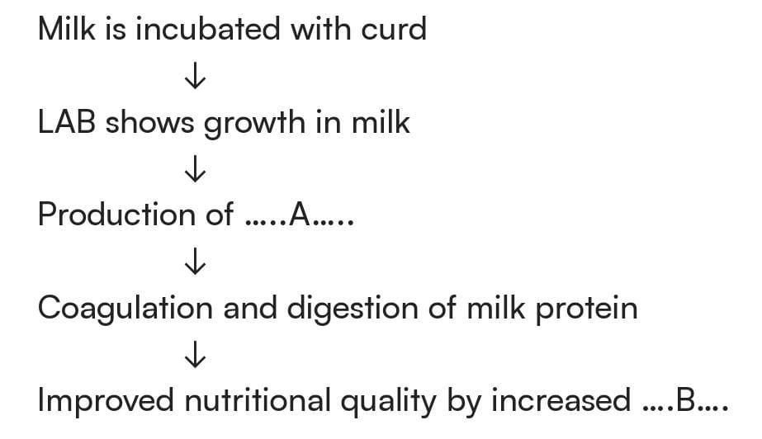

|  |  |  |  |
| --- | --- | --- | --- |
| a) Citric acid , Vit. B12 | b) Lactic acid , Vit. B12 | c) Lactic acid , Vit. C | d) Citric acid , Vit. B2 |

1. Which gas is released during the process of fermentation that gives the puffy appearance to dough for making bread?

|  |  |  |  |
| --- | --- | --- | --- |
| a) CO2 | b) CO | c) O2 | d) H2 |

MICROBES IN HUMAN WELFARE Page No. 1

1. Toddy a traditional drink of Southern India is made by ____A_____ of sap from ___B_____ tree. Find A and B.

|  |  |  |  |
| --- | --- | --- | --- |
| a) fermentation , palm | b) fermentation , bamboo | c) Distillation , palm | d) Distillation , bamboo |

1. Swiss cheese is formed by bacterium?

|  |  |
| --- | --- |
| a) Aspergillus niger | b) Lactobacillus |
| c) Propionibacterium shermanii | d) Penicillium roqueforti |

1. Roquefort cheese is formed by ripening with __________ for a particular flavor. Here A refers to :

|  |  |  |  |
| --- | --- | --- | --- |
| a) Yeast | b) fungi | c) bacteria | d) none of these |

1. Which of the following food items are produced through fermentation by microorganisms?

(i) Idli (ii) Dosa (iii) Toddy (iv) Cheese

|  |  |  |  |
| --- | --- | --- | --- |
| a) (i) , (ii) | b) (iii) , (iv) | c) all of these | d) none of these |

1. Which of the following equipments is essentially required for growing microbes on a large scale, for industrial production of enzymes?

|  |  |  |  |
| --- | --- | --- | --- |
| a) Sludge digester | b) Industrial oven | c) Bioreactor | d) BOD indicator |

1. The alcoholic beverages produced by the distillation of the fermented broth are :

|  |  |
| --- | --- |
| a) Wine and beer | b) Wine , whisky and brandy |
| c) Whiskey , brandy and rum | d) Whiskey , beer and brandy |

1. Which of the following organisms is used in the production of beverages like wine , beer , whiskey , brandy and rum?

|  |  |
| --- | --- |
| a) Clostridium butylicum | b) Aspergillus niger |
| c) Saccharomyces cerevisiae | d) Penicillium notatum |

1. Yeast is used in production of :

|  |  |
| --- | --- |
| a) Citric acid and lactic acid | b) Lipase and pectinase |
| c) Bread and beer | d) Cheese and butter |

1. Brewer’s yeast is :

|  |  |
| --- | --- |
| a) Penicillium notatum | b) Trichoderma polysporum |
| c) Propionibacterium shermanii | d) Saccharomyces cerevisiae |

1. Who observed a mould growing in unwashed culture plate while working on Staphylococcus bacterium?

|  |  |  |  |
| --- | --- | --- | --- |
| a) Ernest chain | b) Alexander Flemming | c) Lamarck | d) Florey |

1. Which one of the following antibiotics was extensively used to treat American soldiers wounded in world war – II ?

|  |  |  |  |
| --- | --- | --- | --- |
| a) Streptokinase | b) Penicillin | c) Statins | d) Neomycin |

1. Who got Nobel Prize in 1945 for the discovery of antibiotic?

|  |  |  |  |
| --- | --- | --- | --- |
| a) Flemming | b) chain | c) Florey | d) all of these |

1. Antibiotics are used to treat diseases like :

|  |  |  |  |
| --- | --- | --- | --- |
| a) Diphtheria | b) leprosy | c) plaque | d) all of these |

1. Which one of the following microbe used in commercial production of Butyric acid?

|  |  |
| --- | --- |
| a) Clostridium butylicum | b) Streptococcus butylicum |
| c) Trichoderma polysporum | d) Saccharomyces cerevisiae |

MICROBES IN HUMAN WELFARE Page No. 2

1. Identify the blank space given in following table:

|  |  |  |
| --- | --- | --- |
| Types of microbes | Scientific names | Commercial products |
| Bacterium | A | Lactic acid |
| Fungus | B | Citric acid |
| C | Acetobacter aceti | Acetic acid |
| Fungus | Penicillium notatum | D |

1. A – Lactobacillus ; B – Aspergillus niger ; C – Bacterium ; D – Penicillin
2. A – Staphylococcus ; B – Clostridium ; C – Yeast ; D – Penicillin
3. A – Lactobacillus ; B – Microsporum ; C – Yeast ; D – Penicillin
4. A – Staphylococcus ; B – Microsporum ; C – Agaricus ; D – Penicillin
5. Which one of the following is correctly matched for the product produced by them?

|  |  |
| --- | --- |
| a) Acetobacter aceti – Antibiotics | b) Methanobacterium – Lactic acid |
| c) Penicillium notatum – Acetic acid | d) Saccharomyces cerevisiae – Ethanol |

1. Select the incorrect pair :
2. Lipases – Used in detergents for removing oil stains.
3. Pectinase and proteases – Used in clarifying fruit juices.
4. Statins – Competitively inhibit the enzyme responsible for cholesterol synthesis.
5. None of the above.
6. Which of the following is used as clot buster for removing clot.

|  |  |  |  |
| --- | --- | --- | --- |
| a) ethanol | b) Statins | c) Cyclosporin - A | d) Streptokinase |

1. Identify the blank space in the given table:

|  |  |  |  |
| --- | --- | --- | --- |
| Types of microbes | Scientific name | Products | Medical applications |
| Fungus | A | Cyclosporin – A | B |
| C | Monascus purpureus | Statin | D |

1. A – Trichoderma polysporum ; B – Used as an immunosuppressive agent ; C – yeast ; D – Blood cholesterol lowering agent.
2. A – Trichoderma polysporum ; B – Blood cholesterol lowering agent ; C – Protozoa ; D – Used as an immunosuppressive agent.
3. A – Clostridium butylicum ; B – Used as clot buster ; C – yeast ; D – Blood cholesterol lowering agent.
4. A – Clostridium butylicum ; B – Blood cholesterol lowering agent ; C – yeast ; D – Used as clot buster.
5. Which of the following is incorrectly matched in the given table?

|  |  |  |  |
| --- | --- | --- | --- |
|  | Microbes | Products | Applications |
| (a) | Monascus purpureus | Statins | Lowering of blood cholesterol |
| (b) | Streptococcus | Streptokinase | Removal of clot from blood vessels |
| (c) | Clostridium | Lipase | Removal of oil stains |
| (d) | Trichoderma | Cyclosporin - A | Immunosuppressive agent |

MICROBES IN HUMAN WELFARE Page No. 3

1. Monascus purpureus is a yeast used commercially in production of :

|  |  |
| --- | --- |
| a) Ethanol | b) Streptokinase for removing clots |
| c) Citric acid | d) Statins , Blood cholesterol lowering agent |

1. Which industrial products are synthesis from microbes :

(i) Antibiotics (ii) Toddy (iii) Bioactive molecules (iv) Bread

|  |  |  |  |
| --- | --- | --- | --- |
| a) all of the above | b) (i) , (iii) | c) (i) , (iv) | d) (iii) , (iv) |

1. Which of the following statement is incorrect?
2. Yeast is used in making bread and beverages is a prokaryotic fungus.
3. Streptokinase is produced by streptococcus and modified by genetic engineering is used as clot buster.
4. Lipase are added in detergents for removing oily stains.
5. Pectinases are used in clearing of bottled fruit juices.
6. Which of the following statement is correct?
7. Ethanol is produced by fermentation of malted cereals and fruit juices.
8. Wine is produced without distillation.
9. Saccharomyces is used for bread making.
10. All of the above
11. Which of the following statements represents the main benefits of LAB?
12. Increase vitamin B12 amount, thus increasing nutrient quality of milk.
13. Check diseases causing microbes in stomach.

|  |  |  |  |
| --- | --- | --- | --- |
| a) Only (i) | b) Only (ii) | c) (i) and (ii) | d) None of these |

1. Consider the following statements :
2. Antibiotics are chemical substance produced by some microorganisms which can kill or retard the growth of other diseases causing organisms.
3. Penicillin was first antibiotics discovered by Alexander Flemming, while working on Staphylococcus bacterium.
4. The function of penicillin as antibiotics established by Chain and Florey.

Which of the following statements are correct?

|  |  |  |  |
| --- | --- | --- | --- |
| a) (i) , (ii) | b) (i) , (iii) | c) (ii) , (iii) | d) all of the above |

1. Which of the following statement are correct?
2. Wine and beer are produced without distillation of fermented broth.
3. By products of alcoholic fermentation are CO2 and methane.
4. Penicillium is used for fermenting malted cereals to produce alcohol.

|  |  |  |  |
| --- | --- | --- | --- |
| a) (i) | b) (i) , (ii) | c) (ii) , (iii) | d) (iii) |

MICROBES IN HUMAN WELFARE Page No. 4

**Answers**

|  |  |  |  |  |  |  |  |
| --- | --- | --- | --- | --- | --- | --- | --- |
| 1. d | 1. b | 1. a | 1. c | 1. b | 1. a | 1. b | 1. a |
| 1. a | 1. c | 1. b | 1. c | 1. c | 1. c | 1. c | 1. c |
| 1. d | 1. b | 1. b | 1. d | 1. d | 1. a | 1. a | 1. d |
| 1. d | 1. d | 1. a | 1. c | 1. d | 1. b | 1. a | 1. d |
| 1. c | 1. d | 1. a |  |  |  |  |  |

MICROBES IN HUMAN WELFARE Page No. 5

|  |
| --- |
| **Neha Malhotra**  **R.L. Institute M: 9416974837**  **Class : XII**  **“MICROBES IN HUMAN WELFARE”** |

**Level – 2**

**(Based on STP and Biogas)**

1. Sewage contains large amounts of __A___ and ___B___ Here, A and B refers to :

|  |  |
| --- | --- |
| a) A – Inorganic waste ; B – Bacteria | b) A – Organic waste ; B – Pathogenic microbes |
| c) A – Organic waste ; B – Virus | d) A – Inorganic waste ; B – Pathogenic microbes |

1. Primary treatment of wastes is the :
2. Physical removal of large and small particles from sewage.
3. Biological removal of large and small particles from sewage.
4. Both (a) and (b)
5. Chemical removal of large and small particles from sewage.
6. In the primary treatment of sewage, the floating debris is removed by sequential____________ by passing through wire mesh screens. The most appropriate word for filling the blank is :

|  |  |  |  |
| --- | --- | --- | --- |
| a) Filtration | b) Sedimentation | c) Condensation | d) Evaporation |

1. In the primary treatment of sewage, the soil and small pebbles are removed by :

|  |  |  |  |
| --- | --- | --- | --- |
| a) Filtration | b) Sedimentation | c) Condensation | d) Evaporation |

1. Which one of the following in sewage treatment removes suspended solids?

|  |  |  |  |
| --- | --- | --- | --- |
| a) Tertiary treatment | b) secondary treatment | c) primary treatment | d) Sludge treatment |

1. Choose the correct option to fill in the blanks.
2. Primary treatment of sewage involves physical and removal of small and large particles through ___A___ and ____B_____.
3. Microbes consume the major part of organic matter in the effluent and reduce ____C____ of sewage.
4. ___D____ particularly ____E____ anaerobically breakdown cellulosic material and produce CO2 and H2 from anaerobic sludge digester during _____F_____ treatment.
5. When BOD of sewage has reduced, the effluent is passes into ____G____. Here A to G can be :
6. A – Sedimentation ; B – Centrifugation ; C – BOD ; D – Methanogens ; E – Methanobacterium ; F – Water gas plant ; G – Settling tank.
7. A – Centrifugation ; B – Sedimentation ; C – BOD ; D – Methanogens ; E – Methanococcus ; F – Biogas plant ; G – Sludge tank.
8. A – Filtration ; B – Centrifugation ; C – BOD ; D – Methanogens ; E – Methanobacillus ; F – Gobar gas plant ; G – Filter tank.
9. A – Filtration ; B – Sedimentation ; C – BOD ; D – Methanogens ; E – Methanobacterium ; F – Sewage treatment plant ; G – Settling tank.

MICROBES IN HUMAN WELFARE Page No. 6

1. In the sewage treatment, bacterial flocs are allowed to sediment in a settling tank. This sedimentation is called as :

|  |  |  |  |
| --- | --- | --- | --- |
| a) Activated sludge | b) Primary sludge | c) anaerobic sludge | d) secondary sludge |

1. In the biological treatment of sewage, the masses of bacteria held together by fungi filament to form mesh-like structure called as :

|  |  |  |  |
| --- | --- | --- | --- |
| a) Activated sludge | b) Aerobic process | c) Flocs | d) Anaerobic sludge |

1. Given below is the flowchart of sewage treatment. Identify A , B , C , D and E , select the correct option:

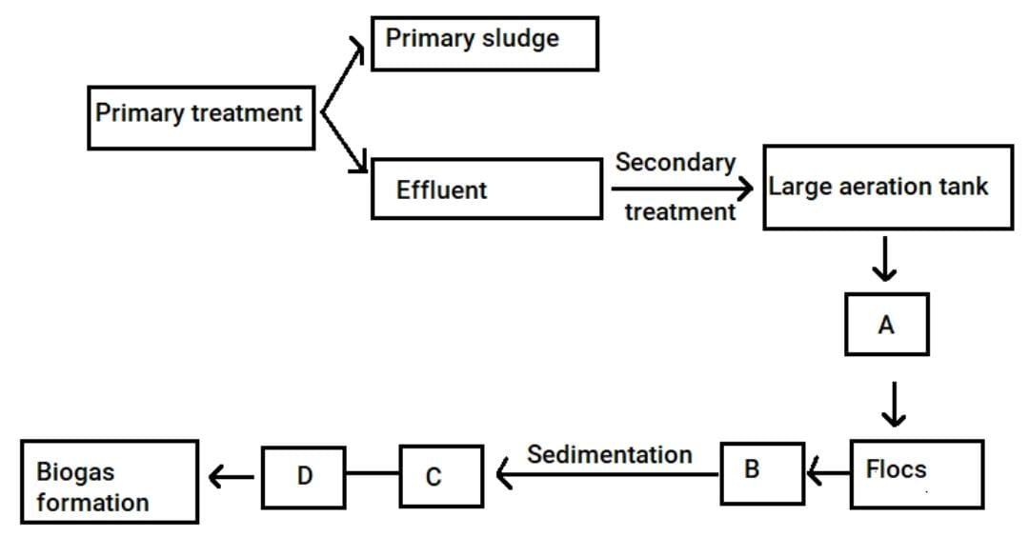

1. A – Small aerated tank ; B – Microbial digestion ; C – High BOD ; D – Activated sludge ; E – Aerobic sludge digester.
2. A – Large aerated tank ; B – Mechanical agitation ; C – High BOD ; D – Activated sludge ; E – Aerobic sludge digester.
3. A – Small aerated tank ; B – Microbial digestion ; C – Low BOD ; D – Activated sludge ; E – Anaerobic sludge digester.
4. A – Large aerated tank ; B – Mechanical agitation ; C – Reduced BOD ; D – Activated sludge ; E – Anaerobic sludge digester.
5. Primary sludge :

|  |  |
| --- | --- |
| a) possess flocs of decomposer microbes | b) requires aeration for formation. |
| c) involves little decomposition | d) Forms during secondary sewage treatment |

1. During sewage treatment plant, biogas is produced which includes :

|  |  |
| --- | --- |
| a) Methane , Hydrogen sulphide , carbon dioxide | b) Methane , oxygen , Hydrogen sulphide |
| c) Methane , Hydrogen sulphide , Sulphur dioxide | d) Methane , nitrogen , Hydrogen sulphide |

1. Microbes are used in :

(i) Primary treatment of sewage (ii) Secondary treatment of sewage (iii) Anaerobic sludge digester (iv) Production of biogas.

|  |  |  |  |
| --- | --- | --- | --- |
| a) (i) , (ii) , (iii) | b) (i) , (iii) , (iv) | c) (ii) , (iii) , (iv) | d) all of the above |

1. The BOD test measures the rate of uptake of oxygen by microbes in water bodies. The greater BOD of sample water, indicates that :

|  |  |
| --- | --- |
| a) it is Highly polluted | b) it is not polluted |
| c) It is moderately polluted | d) pollution level cannot be determined |

1. Which of the following plans has been initiated by the Ministry of Environment and Forests to protect rivers from water pollution?

|  |  |  |  |
| --- | --- | --- | --- |
| a) Ganga action plan | b) Yamuna action plan | c) Both (a) and (b) | d) none of these |

MICROBES IN HUMAN WELFARE Page No. 7

1. Which of the following statement is/are correct?
2. Biochemical oxygen demand (BOD) represent the amount of dissolved oxygen that would be consumed if all the organic matter in 1 L of water were oxidized by microorganisms.
3. Sewage water is treated to reduce its BOD.
4. High value of BOD means the water is less polluted by organic matter
5. Both (a) and (b).
6. Sewage or municipal waste should not be directly passed into rivers, streams and other water bodies because :
7. It contains human excreta and other organic waste.
8. It contains a number of pathogenic microbes.

Select the correct statement :

|  |  |  |  |
| --- | --- | --- | --- |
| a) Only (i) | b) Only (ii) | c) Both (i) and (ii) | d) None of these |

1. Consider the following statement and select the correct statement :
2. After primary treatment of sewage, all solids are settled down forms the primary sludge and the supernatant form the effluent.
3. Spent slurry is used as Biofertilizers.

|  |  |  |  |
| --- | --- | --- | --- |
| a) Only (i) | b) Only (ii) | c) Both (i) and (ii) | d) None of these |

1. Consider the following statement about secondary treatment and select the correct statement:
2. In secondary treatment, useful aerobic microbes grow rapidly and form flocs. Flocs are masses of bacteria held together by fungi filament to form mesh-like structure.
3. The growing microbes consume organic matter and thus increase BOD, When BOD is increase then the effluent is passed into settling tank.
4. In settling tank, the bacterial flocs settle and the sediment is called activated sludge.
5. A small part of the sludge is used as an inoculum in the aerated tank and the remaining part is passed into large tanks called anaerobic sludge digesters.
6. In the digesters, heterotrophic microbes anaerobically digest bacteria and fungi producing mixture of gases such as CO2 , N2 and CO which form biogas.

|  |  |  |  |
| --- | --- | --- | --- |
| a) 1 , 3 , 4 | b) 1 , 3 , 4 , 5 | c) 1 , 2 , 3 , 4 | d) 1 , 2 , 3 , 4 , 5 |

1. The most inflammable gaseous component of biogas is :

|  |  |  |  |
| --- | --- | --- | --- |
| a) CH4 , CO2 , H2 , H2S | b) methane | c) CO2 , H2 , H2S | d) CO , methane |

1. Methanogens are found in :

(i) Organic acid (ii) rumen of cattle (iii) Butanal (iv) anaerobic sludge

|  |  |  |  |
| --- | --- | --- | --- |
| a) (i) , (ii) | b) (ii) , (iii) | c) (ii) , (iv) | d) (iii) , (iv) |

1. Which of the following bacteria is present in rumen of cattle?

|  |  |  |  |
| --- | --- | --- | --- |
| a) Rhizobium | b) Azotobacter | c) Methanobacterium | d) Clostridium |

1. The primitive prokaryotes responsible for the production of biogas from the dung of ruminant animals include the :

|  |  |  |  |
| --- | --- | --- | --- |
| a) Thermoacidophiles | b) Methanogens | c) Eubacteria | d) Halophiles |

MICROBES IN HUMAN WELFARE Page No. 8

1. The diagram given below represents a typical biogas plant. Select the correct option for A , B , C respectively.

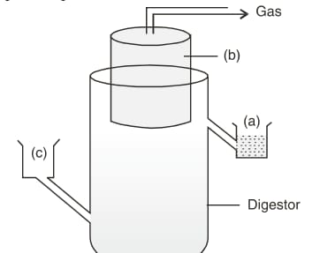

1. A – Sludge ; B – Dung + Water ; C – Gas holder.
2. A – Dung + water ; B – Sludge ; C – CH4 + CO2
3. A – Sludge ; B – Gas holder ; C – Dung + water
4. A – Methane + CO2 ; B – Dung + Water ; C – Gas holder
5. Study the following flowchart of biogas production and select the correct option for A , B and C.

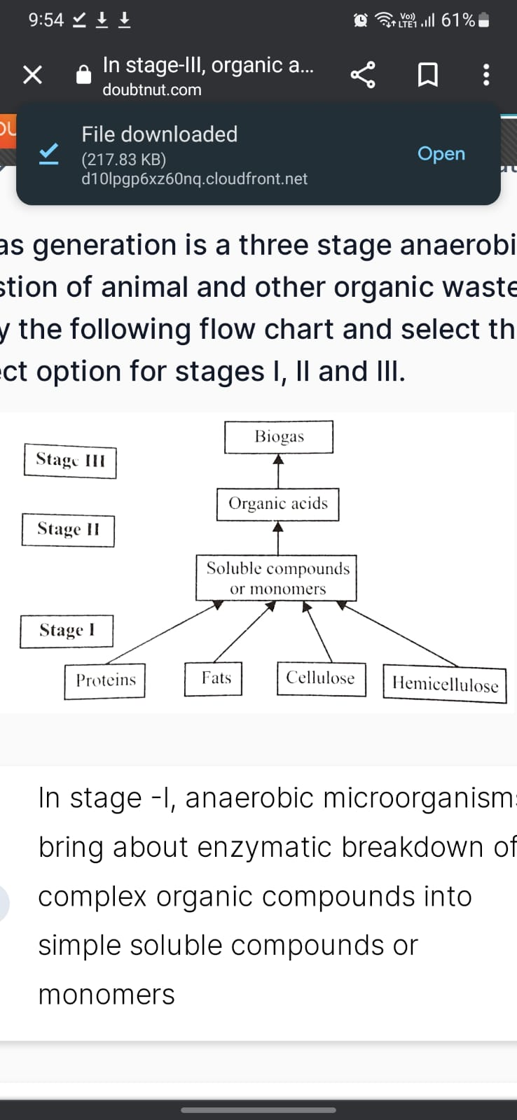

1. A – Methanogenic bacteria ; B – Fermentative microbes ; C – CO2 and Hydrogen (Biogas).
2. A – Anaerobic microorganism ; B – Methanococcus ; C – CO2 and Nitrogen (Biogas).
3. A – Anaerobic microorganism ; B – Methanogenic bacteria ; C – CO2 and Methane (Biogas).
4. A – Aerobic microorganism ; B – Methanobacter ; C – CO2 and Methane (Biogas).
5. Gobar gas generation technology in India was developed by the collaboration of ___A____ and ____B____. Here A and B refers to:
6. A – Rural bank of India ; B – Khadi and village industries commission.
7. A – Indian agriculture research institute ; B – Khadi and village industries commission.
8. A – National bank of agriculture ; B – Indian agriculture research institute
9. A – National bank of India ; B – Khadi and village industries commission

MICROBES IN HUMAN WELFARE Page No. 9

**Answers**

|  |  |  |  |  |  |  |  |
| --- | --- | --- | --- | --- | --- | --- | --- |
| 1. b | 1. a | 1. a | 1. b | 1. c | 1. d | 1. a | 1. c |
| 1. d | 1. c | 1. a | 1. c | 1. a | 1. c | 1. d | 1. c |
| 1. c | 1. a | 1. b | 1. c | 1. c | 1. b | 1. c | 1. c |
| 1. b |  |  |  |  |  |  |  |

**Level – 3**

**Answers**

|  |  |  |  |  |  |  |  |
| --- | --- | --- | --- | --- | --- | --- | --- |
| 1. c | 1. a | 1. d | 1. a | 1. d | 1. c | 1. d | 1. a |
| 1. a | 1. d | 1. d | 1. b | 1. c | 1. c | 1. c | 1. b |
| 1. c | 1. c | 1. d | 1. c | 1. d | 1. d | 1. b | 1. a |

94 d 95 d 96 d 97 d 104 d 105 d 106 c

|  |
| --- |
| **Neha Malhotra**  **R.L. Institute M: 9416974837**  **Class : XII**  **“MICROBES IN HUMAN WELFARE”** |

**Level – 3**

**(Based on Bio control Agents and Biofertilizers)**

1. Bacillus thuringiensis is used as :

|  |  |  |  |
| --- | --- | --- | --- |
| a) Bio fungicide | b) Biopesticide | c) Biocontrol agents | d) Bioweapon |

1. In Bt cotton, the Bt toxin present in the plant tissue as protoxin is converted into active toxin due to :

|  |  |
| --- | --- |
| a) Alkaline pH of insect gut | b) Acidic pH of insect gut |
| c) Action of gut microorganisms | d) the presence of conversion factors in insect gut |

1. Cultivation of Bt cotton has been much in the news. The prefix Bt means :
2. ‘Barium-treated’ cotton seeds.
3. ‘Bigger thread’ variety of cotton with better tensile strength.
4. Produced by ‘Biotechnology’ using restriction enzymes and ligases.
5. Carrying an endotoxin gene from ‘Bacillus thuringiensis’.
6. Trichoderma species, free living fungi, are present in root ecosystem are potentially useful as :

|  |  |  |  |
| --- | --- | --- | --- |
| a) Biopesticides | b) Biofertilizers | c) Methanogens | d) Vector |

1. Which of the following can be used as a biocontrol agent in the treatment of plant diseases?

|  |  |  |  |
| --- | --- | --- | --- |
| a) Chlorella | b) Anabaena | c) Lactobacillus | d) Trichoderma |

1. Baculoviruses (Nucleopolyhedrovirus) do not show

|  |  |
| --- | --- |
| a) Host specificity | b) Narrow spectrum applications |
| c) Effects on non-target insects | d) Utility in IPM programme |

1. A biocontrol agent to be a part of IPM should be :
2. Species – specific and Symbiotic.
3. Free-living and narrow spectrum.
4. Narrow spectrum and symbiotic.
5. Species – specific and inactive on non-target organisms.
6. Select the correct group of biocontrol agents:

|  |  |
| --- | --- |
| a) Trichoderma , Baculovirus , Bacillus thuringiensis | b) Oscillatoria , Rhizobium , Trichoderma |
| c) Nostoc , Azospirillum , Nucleopolyhedrovirus | d) Bacillus thuringiensis , Tobacco mosaic virus , aphids |

1. Organic farming includes :

|  |  |
| --- | --- |
| a) Use of fertilizers & pesticides of biological origin | b) IPM (Integral pest management) |
| c) Locally developed pest resistant varieties | d) All of the above |

MICROBES IN HUMAN WELFARE Page No. 11

1. The organisms which are used to enrich the nutrient quality of the soil are :

|  |  |  |  |
| --- | --- | --- | --- |
| a) Bacteria | b) Cyanobacteria | c) Fungi | d) All of these |

1. The most important of the symbiotic nitrogen-fixing bacteria, which forms nodules on the roots of legume plants is :

|  |  |  |  |
| --- | --- | --- | --- |
| a) Aspergillus | b) Rhizobium | c) Penicillium | d) Streptococcus |

1. Among the following pairs of microbes, which pair has both the microbes hat can be used as Biofertilizers?

|  |  |
| --- | --- |
| a) Aspergillus and Rhizopus | b) Rhizobium and Rhizopus |
| c) Cyanobacteria and Rhizobium | d) Aspergillus and cyanobacteria |

1. Which of the following belongs to free-living nitrogen-fixing bacteria?

(i) Rhizobium (ii) Azospirillum (iii) Azotobacter ; Select the correct option :

|  |  |  |  |
| --- | --- | --- | --- |
| a) (i) and (ii) | b) (i) and (iii) | c) (ii) and (iii) | d) All of these |

1. The symbiotic association of fungi with the roots of higher plants is called :

|  |  |  |  |
| --- | --- | --- | --- |
| a) Eubacteria | b) Actinomycetes | c) Mycorrhiza | d) Lichens |

1. The most common fungal partners of mycorrhiza belongs to genus :

|  |  |  |  |
| --- | --- | --- | --- |
| a) Azotobacter | b) Glomus | c) Azolla | d) Frankia |

1. Which one of the following helps in absorption of phosphorus from soil?

|  |  |  |  |
| --- | --- | --- | --- |
| a) Nostoc | b) Anabaena | c) Glomus | d) yeast |

1. Which of the following are the part or example of symbiotic mutualistic association?

|  |  |  |  |
| --- | --- | --- | --- |
| a) Rhizobium | b) Mycorrhiza | c) Both (a) and (b) | d) Oscillatoria |

1. Which of the following is cyanobacteria and fix atmospheric nitrogen?

|  |  |  |  |
| --- | --- | --- | --- |
| a) Oscillatoria | b) Nostoc | c) Anabaena | d) All of these |

1. Which of the following is common to Azospirillum , Anabaena , Nostoc and Oscillatoria?

|  |  |  |  |
| --- | --- | --- | --- |
| a) N2 fixer microbes | b) prokaryotic organisms | c) Eukaryotic organisms | d) Both (a) and (b) |

1. Which of the following serves as biofertilizers in paddy fields ?

|  |  |  |  |
| --- | --- | --- | --- |
| a) Anabaena | b) Azospirillum | c) Nostoc | d) Both (a) and (c) |

1. Azolla is used as a biofertilizers because it :
2. Has association of mycorrhiza.
3. Multiplies at faster rate to produce massive biomass.
4. Has association of nitrogen- fixing microbes.
5. Has association of nitrogen- fixing cyanobacteria.
6. Benefits of mycorrhiza are indicated by which statement?
7. It shows a resistance to root borne pathogen.
8. It shows tolerance to salinity and pathogen.
9. It helps in the overall increase in the plant growth and development.
10. All of the above.
11. Which of the following statement regarding baculovirus as biocontrol agent are correct?
12. Baculovirus are the pathogen that attacks insects and other arthropods.
13. Most of these biocontrol agents belong to the genus Nucleopolyhedrovirus.
14. They do not harm plants , mammals , birds , fish and other on-target insects.
15. All of the above.

MICROBES IN HUMAN WELFARE Page No. 12

1. A biocontrol agent used for pest butterfly caterpillars is :

|  |  |  |  |
| --- | --- | --- | --- |
| a) Trichoderma | b) BT | c) Pseudomonas | d) Rhizobium |

1. Consider the following statement about organic farming. Which of the following statement is correct?
2. Organic farming promotes the use of crop rotations, cover crops and encourages balanced host/predator relationships.
3. Integral pest , weed management and soil conservation systems are valuable tools of an organic farm.
4. Organic farming protects the environment, minimize soil degradation and erosion and decrease pollution.
5. All of these.
6. Consider the following statements and select the incorrect statements?
7. Microbes are also used to fermented fish, soyabean and bamboo shoots to make foods.
8. Different varieties of cheese are known by their characteristic texture, flavor and taste, the specificity comes from the microbe used.
9. Trichoderma free-living fungi, are present in root ecosystems where they act against several plant pathogens.
10. Rhizobium is a symbiotic bacterium that lives in the stem of legumes.
11. Consider the following statements about Bt and select the correct ones:
12. The bacteria Bacillus thuringiensis are used to control butterfly caterpillar.
13. Fresh spores of Bt are mixed with water and sprayed on to vulnerable plants such as brassicas and fruit trees.
14. Insect larvae, after eating BT are killed by toxin released in their gut.
15. Bt toxin gene have been introduced into plants to provide resistance to pests.

|  |  |  |  |
| --- | --- | --- | --- |
| a) (i) , (ii) , (iii) | b) (i) , (iii) , (iv) | c) (ii) , (iii) , (iv) | d) (i) , (ii) , (iii) , (iv) |

1. Which of the following is/are the approachable for biological farming?
2. Familiarity with various life forms inhabiting the field.
3. Gain knowledge about the life cycles, patterns of feeding the habitat of predators and pests.

|  |  |  |  |
| --- | --- | --- | --- |
| a) Only (i) | b) Only (ii) | c) Both (a) and (b) | d) none of these |

1. Read the following statements and select the correct statements:
2. Biocontrol agents refers to the use of biological methods for controlling plant diseases and pests.
3. Use of biocontrol measures will greatly reduce our dependence on toxin chemicals and pesticides.

|  |  |
| --- | --- |
| a) Both statement (i) and (ii) are correct. | b) Statement (i) is correct & statement (ii) incorrect |
| c) Statement (i) is incorrect & statement (ii) correct | d) Both statement (i) and (ii) are incorrect |

1. Read the following statements about disadvantages of chemical agents.
2. Chemicals are toxic and harmful to human beings and animals.
3. Chemicals pollute the environment and forests.
4. Weedicides used to remove weeds also pollute the soil.

Select the correct options:

|  |  |  |  |
| --- | --- | --- | --- |
| a) (i) , (ii) , (iii) | b) (i) , (ii) | c) (i) , (iii) | d) (ii) , (iii) |

MICROBES IN HUMAN WELFARE Page No. 13

1. e microscopic proteinaceous infectious agents are :

|  |  |  |  |
| --- | --- | --- | --- |
| a) | b) | c) | d) |

1. Which of the following bacteria convert milk into curd?

|  |  |
| --- | --- |
| a) | b) |
| c) | d) |